Alex McLaurian
2-14-14
CS 5560

Lab 2

For lab 2, I utilized JqueryMobile, HTML5, and Google Maps/Places API. The design and layout is optimized for mobile phones, as shown here:
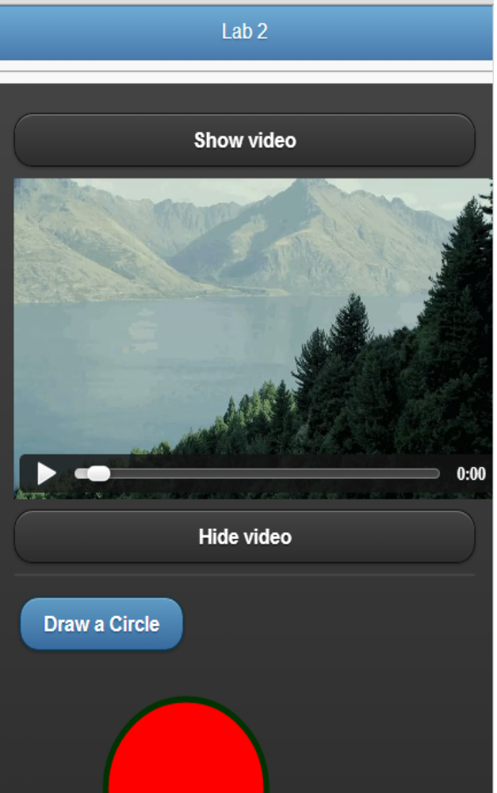
The video is an HTML5 video with a webm format, and is accessible via clicking the button. Clicking the draw circle button triggers a JS functions that utilizes HTML5's ability to draw any shape on the screen. The Google Map has an autcomplete functionality which takes advantage of Google Places API, bringing up local listings as you type specific names in.

